A Review on Convolutional Neural Networks (CNN) in Skin Cancer Diagnosis
Khor Feng Rong
Abstract
This paper provides a detailed review of Convolutional Neural Networks (CNN) in skin cancer diagnosis systems. It thoroughly explores the process of optimizing CNNs for skin cancer diagnosis systems and their benefits in said systems. Furthermore, current issues impeding advancements and suggestions on improving this technology for future use are also discussed in this paper. Finally, this paper concludes that findings show that CNNs have promising potential to be utilised in aiding dermatologists to diagnose skin cancer in the near future.
Introduction
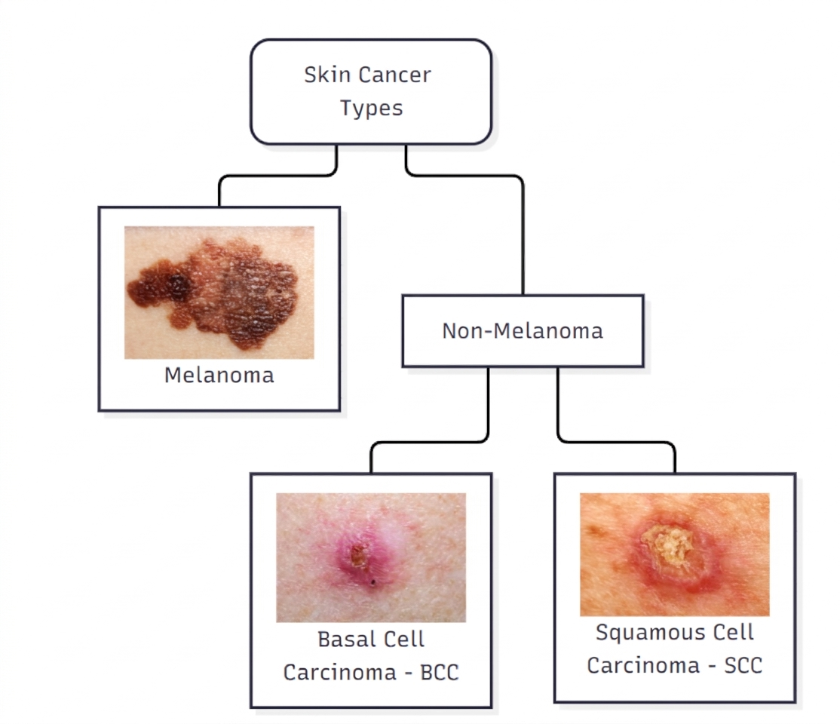
Figure 1: The different primary types of skin cancer
Skin cancer is a fatal type of malignancy that is caused by faulty DNA in skin cells, which leads to genetic defects or mutations in the skin^{[1]}. In modern times, skin cancer has become the fifth most common type of cancer^{[2]} and has two primary types: melanoma and non-melanoma skin cancer^{[1]}(Figure 1). Melanoma is much deadlier than the other^{[1]} as it can grow rapidly and even metastasise^{[3]}, which significantly decreases the chances of survival^{[4]}. Non-melanoma skin cancer, which is much more curable^{[1]}, is further split into two main types: basal cell carcinoma (BCC) and squamous cell carcinoma (SCC)^{[1]}, with the former accounting for 80 to 85% of all non-melanoma cases and the latter accounting for the rest^{[2]}. Thus, it is paramount that skin cancer is accurately diagnosed and detected early to improve the chances of survival, decrease medical treatment costs, and prevent severe health complications^{[5]}.
To solve this, Convolutional Neural Networks (CNNs), a specialized type of deep learning model known for performing exceptionally in analyzing complicated patterns and subtle visual features^{[3]}, have been identified as a promising tool for being used in skin cancer diagnosis systems. Before this, they have already been widely used in computer vision tasks such as image classification, object detection, and video prediction^{[6]}. This is because they work by analysing image data, typically in formats such as tensors, vectors, and matrices, extracting its features, and making predictions based on said features to conclude what class or category the image belongs to^{[7]}. Thus, CNNs have been adapted for use in skin cancer diagnosis systems because of their accuracy and reliability at delivering diagnoses from medical images or dermoscopic images. In fact, their accuracy is comparable or even better than professional human dermatologists^{[3]}. Many architectures of CNNs have been utilised for this specific scenario, such as AlexNet^{[8]}, VGG, and GoogLeNet^{[6]}. Moreover, optimised and lightweight architectures, such as NASNetMobile^{[3]}, MobileNetV2^{[6],} and MobileNet^{[9]}, have been developed specifically for deployment on common hardware without greatly affecting accuracy. However, issues such as overfitting, underfitting^{[10],} and limited deployment^{[8]} significantly impact their advancements and widespread usage.
How CNN models are optimized
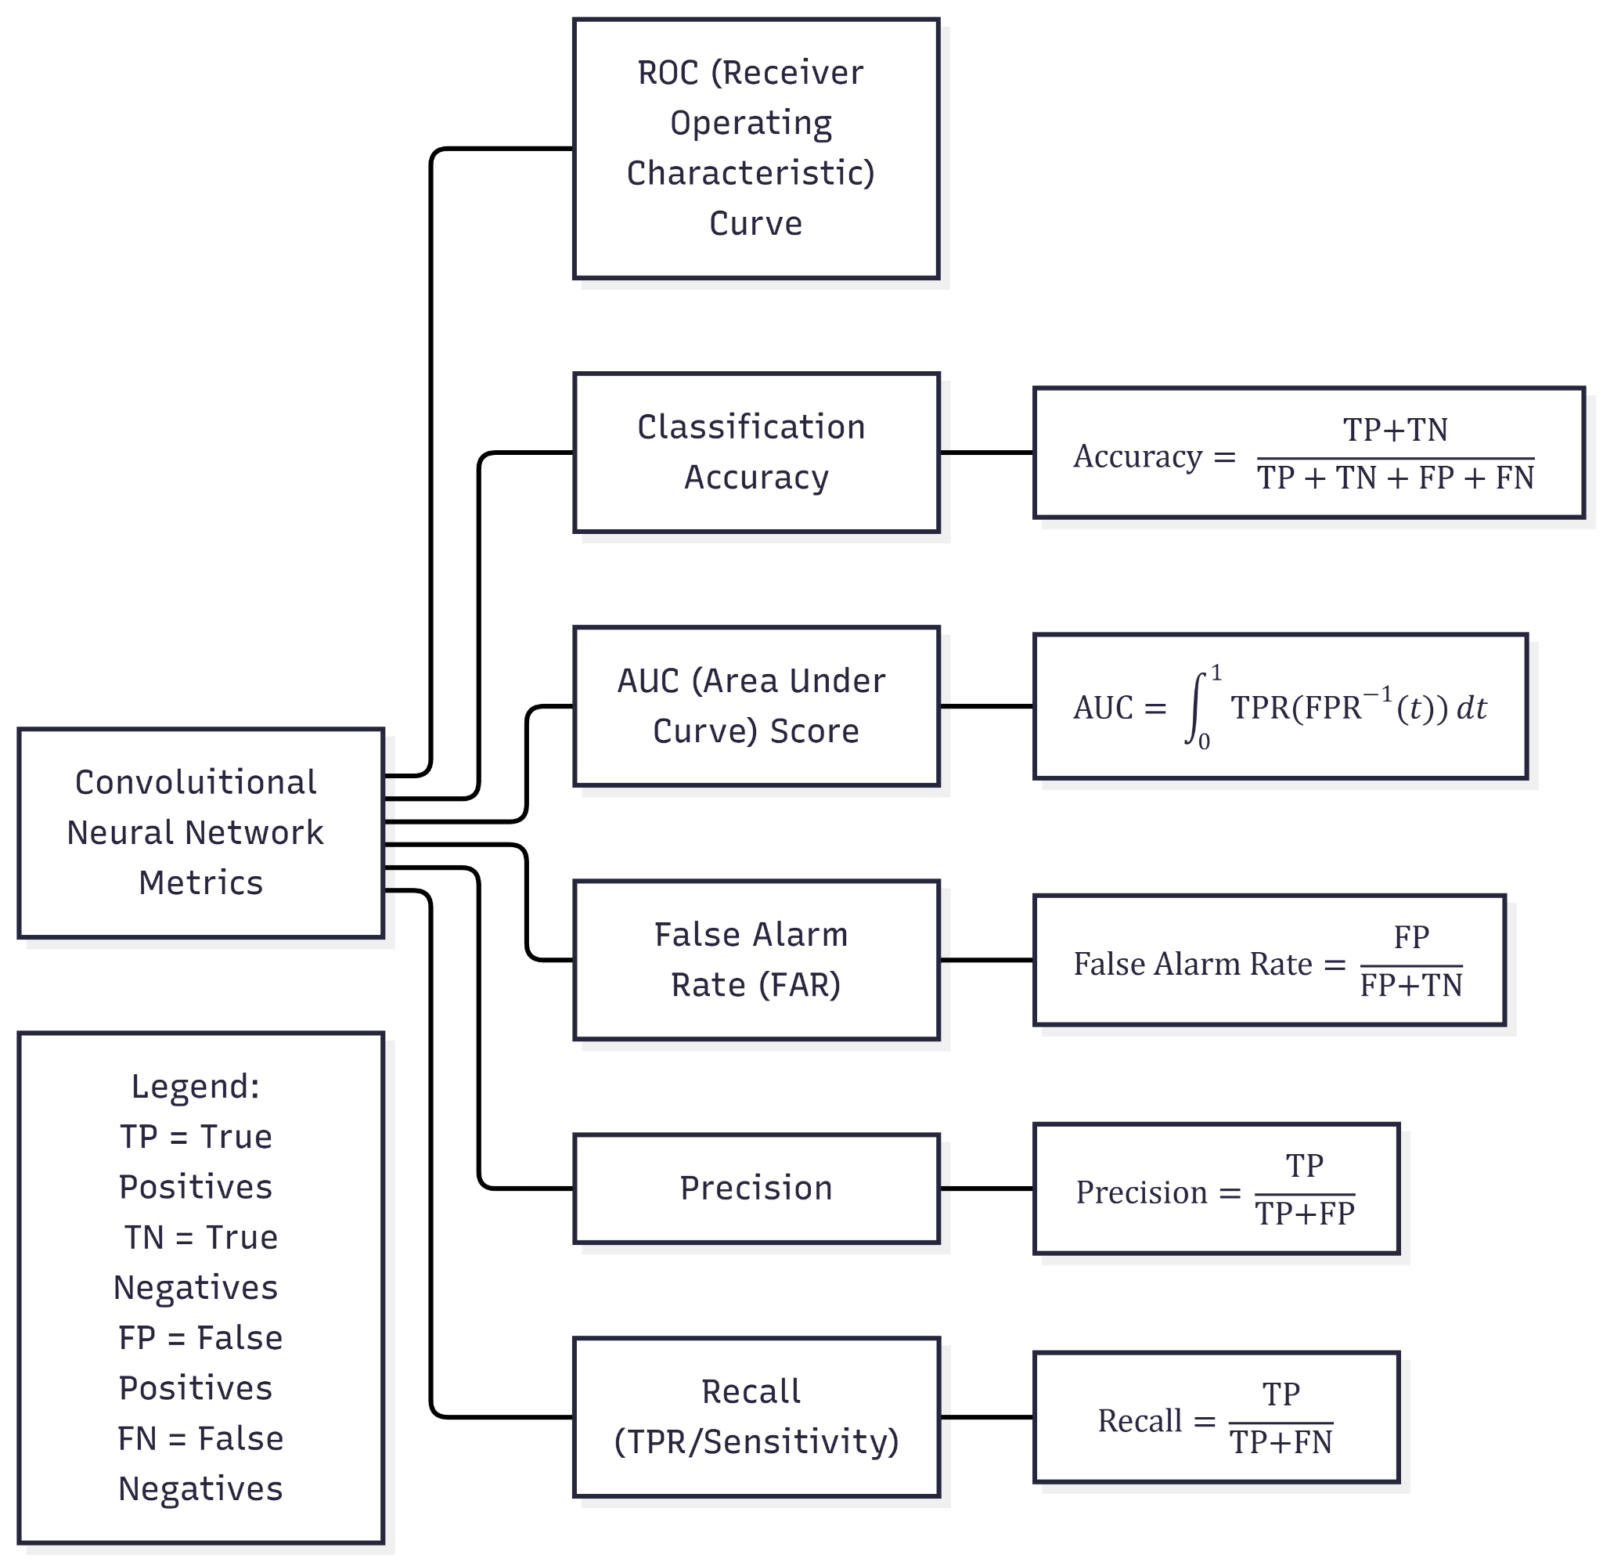
Figure 2: Examples of the metrics collected during a CNN model’s performance evaluation
Before CNN models are officially used for skin cancer diagnosis systems, their performance is evaluated after training using a collection of crucial metrics. These metrics provide invaluable insight into deciding how to optimise a model further. Common evaluation metrics of a CNN model are classification accuracy, recall, precision, false alarm rate (FAR), AUC score, and ROC curve^{[10]}(Figure 2). Classification accuracy is defined as the model’s capability to precisely classify samples in comparison to the total number of samples in an evaluation dataset^{[10]}. Recall, or sometimes called the sensitivity or the true positive rate (TPR), shows a model’s rate of correctly classified positive samples^{[10]}. Precision is defined as the proportion of obtained samples that are relevant and is calculated as the ratio of accurately classified samples to all of the samples in a specific class^{[10]}. False Alarm Rate (FAR) indicates how frequently wrong predictions are made by the model^{[10]}. AUC (Area Under Curve) score shows the performance of a model in differentiating between classes, while the ROC (Receiver Operating Characteristic) curve graphically explains the relationship between the false positive rate and the true positive rate of a classifier in a model^{[10]}. These metrics are invaluable to minimising false diagnoses and maximizing accurate ones in high-stake real world medical applications where lives are at risk.
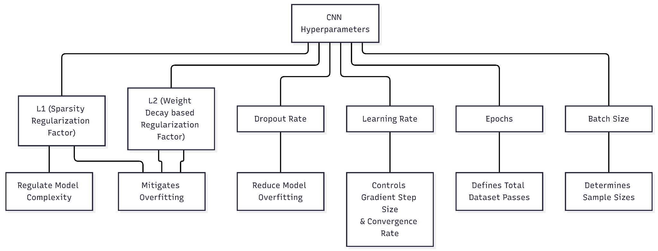
Figure 3: Examples of a CNN's hyperparameters
After obtaining metrics data, models are optimized by tuning their hyperparameters^{[10]}. Hyperparameters heavily influence how a model’s performance will end up and are therefore crucial to be tuned appropriately. Some hyperparameters include learning rate, dropout rate, batch size, epochs, L1 and L2^{[10]}(Figure 3). Learning rate controls how big a step a model takes each time to update its internal parameters in response to the approximate error during training^{[10]}. Dropout rate is where random neurons in the CNN are chosen and dropped out based on the preselected dropout rate while training to reduce the time spent and model overfitting^{[10]}. Batch size regulates the number of training samples fed into the CNN before internal model parameters are refreshed and are generally kept small^{[10]}. L1, also called a sparsity regularization factor, is used to remove the effect of noisy input nodes in the CNN and simplify said CNN^{[10]}. L2 is a regularization factor based on weight decay^{[10]}. Together, both L1 and L2 are used to regulate model complexity and decrease overfitting^{[10]}.
However, it is important to note that a model’s performance is also affected by many factors other than hyperparameters. Some notable examples include a dataset’s quality^{[3]}, label noise^{[11],} and annotation accuracy^{[3]}.
The benefits of CNNs in skin cancer diagnosis
Although CNNs have only been a new addition, their benefits have been apparent. The first and most notable impact it has had on skin cancer diagnosis is being able to help dermatologists in precisely diagnosing skin cancers promptly ^{[8]} as well as prevent potential misdiagnoses made by the dermatologist, which can lead to the unfortunate death of a patient^{[12]}. Moreover, CNNs can reduce the reliance on traditional methods such as clinical examinations, dermoscopy^{[4]} and excisions^{[13]} for diagnosis, which are all prone to human error. Thus, using CNNs on computers solves these problems by making the delivery of diagnoses much more efficient and less costly^{[1]} whilst also easing patient anxiety^{[3]}.
Current issues affecting CNNs
Despite CNNs having the potential to be integrated into skin cancer diagnosis systems, there are a multitude of issues stopping it from being widely adopted and improved on. The first and most apparent issue is the high hardware requirements needed for a device in order to have an accurate CNN deployed on it^{[1]}. In many medical facilities, such devices are either unavailable or too expensive to invest in. Moreover, the time spent training a CNN model is very long^{[8]}, which therefore slows down optimizations and metric evaluation work too. The optimization process itself is also difficult, as hyperparameter tuning requires substantial knowledge and skill^{[6]}. In addition, CNNs are prone to fitting issues, such as overfitting and underfitting^{[10]}, that significantly impact their ability to deliver accurate results. Overfitting occurs when a CNN model performs well on training data but poorly on unfamiliar data^{[10]}. In general, overfitting is more common and caused by a small training dataset, an imbalanced dataset, or the sheer complexity of the model itself^{[10]}. Some hyperparameters, such as learning rate, batch size, L1 and L2, are also influential in causing overfitting^{[10]}. On the other hand, underfitting occurs when a model performs badly on both training data and unfamiliar data^{[10]}. Underfitting is often caused by a model not being trained sufficiently, being excessively regularized, or not having relevant predictive features^{[10]}. When diagnosing different groups of people in real-world medical settings, underfitting and overfitting become dangerous issues that may cause the model to deliver misdiagnoses. For medical personnel, they may find these CNNs untrustworthy in skin cancer diagnosis because of the current lack of interpretability and the complex nature of a CNN^{[7]}. Thus, this may cause them to object to using these tools, which will hamper their adoption and usage in real-world settings.
Suggestions to improve CNNs
In order to improve CNNs to the extent that they are usable in real-world scenarios, many improvements have to be made. Firstly, further research and improvements can be directed towards existing CNN algorithms to improve their performance in diagnostic models^{[1]}. Moreover, the incorporation of ensemble learning, which is the act of combining multiple diverse CNN architectures to help enhance the resulting model’s robustness and generalization to a wider array of image categories, can also be done to create better models^{[6]}. New hybrid architectures can also be developed to leverage the efficiency of some architectures, such as MobileNet and MobileNetV2, and feature extraction capabilities of other architectures, such as VGG and GoogLeNet, which improves their robustness and capabilities^{[3]}. To significantly reduce a model’s training time, an already trained model can be used to learn new information in skin cancer, otherwise known as transfer learning, to improve its performance^{[2]}. Other than that, a model’s hyperparameters can be automatically tuned using meta-heuristic algorithms instead of requiring humans to spend countless hours manually tuning them^{[6]}. Attention mechanisms can also be incorporated into CNN models to improve their metrics and thus their diagnostic accuracy^{[2]}. An attention mechanism takes inspiration from the human eye when analysing an image; it focuses on important areas and disregards less important areas^{[6]}, and has three primary types: self-attention (SL), hard attention (HD), and soft attention (SF)^{[2]}. These attention mechanisms prevent a model from making abrupt decisions that are inaccurate^{[2]}. Most importantly, to improve trust in CNN models among medical personnel, advanced visualization techniques, such as heatmaps and saliency maps, can be implemented in CNN models to make them more interpretable^{[3]}. Thus, medical staff can understand why a model made their decision and verify it themselves.
Conclusion
Convolutional Neural Networks (CNNs) have shown potential for being used in skin cancer diagnosis systems to help both dermatologists and patients alike. However, current issues that stem from human distrust, hardware limitations, and model inaccuracies prevent it from being widely adopted in medical settings. Thus, further research and resources should be given in order to refine these models for real-world use. Once these hurdles have been overcome, CNNs may prove to be a valuable ally in combating cancer around the globe.
Acknowledgements
No external aid or funding was used for this paper.
References
1. Dildar, Mehwish, Shumaila Akram, Muhammad Irfan, Hikmat Ullah Khan, Muhammad Ramzan, Abdur Rehman Mahmood, Soliman Ayed Alsaiari, Abdul Hakeem M. Saeed, Mohammed Olaythah Alraddadi and Mater Hussen Mahnashi. “Skin Cancer Detection: A Review Using Deep Learning Techniques.” International Journal of Environmental Research and Public Health 18, no. 10 (2021): 5479. https://doi.org/10.3390/ijerph18105479.
2. Alotaibi, Areej, and Duaa AlSaeed. “Skin Cancer Detection Using Transfer Learning and Deep Attention Mechanisms.” Diagnostics 15, no. 1 (2025): 99. https://doi.org/10.3390/diagnostics15010099.
3. Kreouzi, Magdalini, Nikolaos Theodorakis, Georgios Feretzakis, Evgenia Paxinou, Aikaterini Sakagianni, Dimitris Kalles, Athanasios Anastasiou, Vassilios S. Verykios and Maria Nikolaou. “Deep Learning for Melanoma Detection: A Deep Learning Approach to Differentiating Malignant Melanoma from Benign Melanocytic Nevi.” Cancers 17, no. 1 (2025): 28. https://doi.org/10.3390/cancers17010028.
4. Chen, Jennifer Y., Kristen Fernandez, Raj P. Fadadu, Rasika Reddy, Mi-Ok Kim, Josephine Tan and Maria L. Wei. “Skin Cancer Diagnosis by Lesion, Physician, and Examination Type: A Systematic Review and Meta-Analysis.” JAMA Dermatology 161, no. 2 (2025): 135–46. https://doi.org/10.1001/jamadermatol.2024.4382.
5. Janda, Monika, Catherine Olsen, Victoria Mar, and Anne Cust. “Early Detection of Skin Cancer in Australia – Current Approaches and New Opportunities.” Public Health Research & Practice 32, no. 1 (2022): e3212204. https://doi.org/10.17061/phrp3212204.
6. Zhao, Xia, Limin Wang, Yufei Zhang, Xuming Han, Muhammet Deveci, and Milan Parmar. “A Review of Convolutional Neural Networks in Computer Vision.” Artificial Intelligence Review 57, no. 4 (2024): 99. https://doi.org/10.1007/s10462-024-10721-6.
7. Tran, Khoa A., Olga Kondrashova, Andrew Bradley, Elizabeth D. Williams, John V. Pearson, and Nicola Waddell. “Deep Learning in Cancer Diagnosis, Prognosis and Treatment Selection.” Genome Medicine 13, no. 1 (2021): 152. https://doi.org/10.1186/s13073-021-00968-x.
8. Naqvi, Maryam, Syed Qasim Gilani, Tehreem Syed, Oge Marques, and Hee-Cheol Kim. “Skin Cancer Detection Using Deep Learning—A Review.” Diagnostics 13, no. 11 (2023): 1911. https://doi.org/10.3390/diagnostics13111911.
9. Mane, Deepak, Rashmi Ashtagi, Prashant Kumbharkar, Sandeep Kadam, Dipmala Salunkhe, and Gopal Upadhye. “An Improved Transfer Learning Approach for Classification of Types of Cancer.” Traitement Du Signal 39, no. 6 (2022): 2095–101. https://doi.org/10.18280/ts.390622.
10. Xu, Chuhan, Pablo Coen-Pirani, and Xia Jiang. “Empirical Study of Overfitting in Deep Learning for Predicting Breast Cancer Metastasis.” Cancers 15, no. 7 (2023): 1969. https://doi.org/10.3390/cancers15071969.
11. Hekler, Achim, Jakob N. Kather, Eva Krieghoff-Henning, Jochen S. Utikal, Friedegund Meier, Frank F. Gellrich, Julius Upmeier zu Belzen, Lars French, Justin G. Schlager, Kamran Ghoreschi, Tabea Wilhelm, Heinz Kutzner, Carola Berking, Markus V. Heppt, Sebastian Haferkamp, Wiebke Sondermann, Dirk Schadendorf, Bastian Schilling, Benjamin Izar, Roman Maron, Max Schmitt, Stefan Fröhling, Daniel B. Lipka and Titus J. Brinker. “Effects of Label Noise on Deep Learning-Based Skin Cancer Classification.” Frontiers in Medicine 7 (May 2020). https://doi.org/10.3389/fmed.2020.00177.
12. Meedeniya, Dulani, Senuri De Silva, Lahiru Gamage, and Uditha Isuranga. “Skin Cancer Identification Utilizing Deep Learning: A Survey.” IET Image Processing 18, no. 13 (2024): 3731–49. https://doi.org/10.1049/ipr2.13219.
13. Gilmore, Stephen J. “Automated Decision Support in Melanocytic Lesion Management.” PLOS ONE 13, no. 9 (2018): e0203459. https://doi.org/10.1371/journal.pone.0203459.

